Health and Wellbeing Strategy 2025–2029

Reconciliation Acknowledgement Statement
We acknowledge the City of Stonnington is situated on the Traditional Lands of the Wurundjeri Woi-wurrung and Bunurong peoples of the East Kulin Nations and pay our respect to their Elders past and present.
We extend that respect to all Aboriginal and Torres Strait Islander peoples. We acknowledge their living connection to Country, relationship with the land and all living things extending back tens of thousands of years.
Commitment to preventing family and gender-based violence
We stand firmly against all forms of violence, including violence against women, children and LGBTIQA+ people. We acknowledge the serious and long-lasting impacts of family and gender-based violence on individuals, families and communities. These harms are preventable, driven by gender inequality and discrimination.

We’re committed to building a community where everyone is safe, respected and free from violence. We’ll continue to work with our partners to promote gender equality, support victim-survivors, and prevent violence before it starts.
Commitment to Child Safety
The City of Stonnington has a zero tolerance to child abuse and is committed to the safeguarding of all children and young people. We will champion a culture of safety and utilise our specific policies, procedures and practices to support our people and community.

Message from the Mayor

Contents
About this strategy 5
Guiding principles 5
Our partners 6
How we developed this strategy 7
How this strategy fits with others 8
Health and wellbeing in Stonnington 9
What influences our health and wellbeing? 9
Priority populations 9
Our community 10
Our city 11
Our health and wellbeing 13
Our priorities 14
Priority 1: Community safety and all forms of violence 15
Why this matters 15
What we know 15
What we’ll do 16
Priority 2: Social connection and inclusion 19
Why is this important? 19
What we know 19
What we’ll do 19
Priority 3: Active and sustainable living 22
Why this matters 22
What we’ll do 23
Monitoring and Evaluation 25
References 25
Data sources 25
Appendix 1 26
Appendix 2 27
Appendix 3 28

About this strategy
Our Health and Wellbeing Strategy 2025-29 sets out how we’ll work to improve the health and wellbeing of our community over the next four years. With a strong focus on prevention, it defines where we will focus, what we want to achieve, and the partnerships we’ll need to support a healthier, more inclusive Stonnington.
While we’ve led the development of this strategy, we know that change requires a collective and sustained effort from all levels of government, health services, local organisations, businesses, communities, families, and individuals.
Developed alongside the Council Plan 2025-29 and shaped by community feedback and local data, this strategy meets our legislated responsibilities under the Victorian Public Health and Wellbeing Act 2008. It guides a suite of existing plans focused on safety, access, and inclusion.
The strategy focuses on three priority areas:
- Community safety and all forms of violence
- Social connection and inclusion
- Active and sustainable living
Implementation will be coordinated through the Health and Wellbeing reference group and progress will be monitored and reported through our CEO Quarterly Update and Annual Report.

Guiding principles
Our strategy is guided by six key principles that describe our approach:

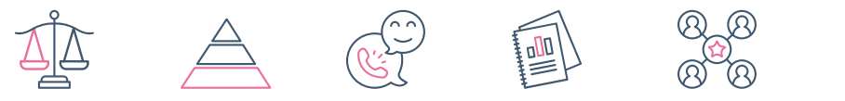

Fairness and equity | Prevention focused | Community led | Evidence informed | Partnership driven | Resourcing and capacity
We want everyone to have a fair opportunity to live a healthy life and recognise that people need different kinds of supports to achieve the same outcomes. | We’re focused on keeping people well by addressing the social, environmental and systemic factors that shape our health, and taking early action to reduce future harm. | We listen to our community and work together to understand what matters most and what kind of response will make the greatest difference. | We use data, research and local insights to guide what we do and how we do it. | We work across sectors and services to align efforts, strengthen impact, and support a connected, community-wide response. | We assess whether Council and its partners have the necessary capacity, capability and resources to effectively support or implement the initiative.

Our partners
Improving health and wellbeing takes more than any one organisation – it requires strong partnerships and shared goals.
We’re proud to work alongside a range of dedicated partners who bring their expertise, experience and community connections to this work. By working together, we can build on shared strengths, make better use of resources, and achieve greater impact than we could on our own.
The Health and Wellbeing Reference Group meet quarterly and brings together key partners to guide the development, implementation and evaluation of this Strategy. Members of the group include:
- City of Stonnington
- South East Public Health Unit (SEPHU)
- Better Health Network (BHN)
- Caulfield Community Health, Alfred Health (CCH)
- Women’s Health in the South-East (WHISE)
- Thorne Harbour Health (THH)
We also work closely with other valued partners who support our sub-committees and strategy implementation, including:
- Victoria Police
- Launch Housing
- Salvation Army
- Australian Drug Foundation
- Vic Health
- Victorian Department of Health

In addition, community sports clubs, community groups, local businesses, schools, and early years services are vital partners in the implementation of this Strategy and in connecting with our community.

How we developed this strategy
We developed this Strategy in close partnership with our community, local services and expert stakeholders. It’s grounded in evidence and shaped by lived experience.
Planning began in June 2024 and built on our previous Health and Wellbeing Plan 2021-25. It included:
- A review of current policy and research
- Detailed analysis of local health and demographic health data
- Development of the 2025 Community Health and Wellbeing Data Profile
- Ongoing input from our Health and Wellbeing Reference Group
We engaged widely, both inside and outside of Council, to help shape our priorities. This included:
- Roundtable workshops and advisory committee discussions
- Targeted discussions with key Council work areas, external partners and service providers
- Consultation with the Internal Strategy Network to support alignment with the Council Plan and other strategic priorities
Our broader community engagement included:
- Online consultation via the Connect Stonnington portal
- Pop-up consultation at local events
- Focused engagement with young people and multicultural groups
- The 2025 Health and Wellbeing Survey, which captured barriers and enablers of health and wellbeing
- Deliberative engagement through a demographically representative People’s Panel
- Community feedback on the draft strategy during public exhibition
We also drew insights from engagement undertaken as part of the Community Vision and Council Plan 2025–2029. Together, this input helped shape a strategy that reflects local needs, values and aspirations.
Graphic idea: quotes/insights from Community Engagement i.e., People’s Pannel, Youth Forum, Event feedback:
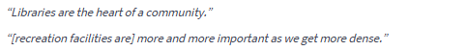People’s Panel 2025

Events (like this) foster community and are great to have for free to encourage a greater breadth of demographics in the audience. Candlelight Concert Prahran Square 2025
Young people want activities not centered around alcohol or scheduled at night, for example, park runs at a suitable time rather than a Saturday morning as young people work on weekends, Youth Consultation
Connecting bike paths, tracks around ovals so it is easier to push a pram or ride a bike. Youth Consultation
Having to prioritise where you spend money because everything is expensive. Youth Consultation
Falls prevention is very important, Spanish Community Group

How this strategy fits with others
This Strategy sits within our broader strategic planning framework and aligns with state and federal policy directions. A more detailed view of this is available in Appendix 1.
Community Vision 2040
Our Community Vision and its six supporting principles reflect our community’s aspirations for the future of our city. This strategy supports the vision by focusing on health and wellbeing outcomes that help people feel safe, connected, supported and able to live well.
Community Vision 2040
Welcome to Stonnington 2040.
A modern, sustainable and interconnected community that supports the good health and wellbeing of all.
Our community is a safe, accessible and creative city that celebrates and embraces all cultures including First Nations peoples past and present.
Safeguard the character, heritage, and history of streetscapes whilst growing sustainably in the interest of the community | Take climate and environmental action, protect biodiversity and pursue eco-friendly ways of living, guided by the United Nations Sustainable Development Goals | Be a caring and compassionate city that promotes and facilitates opportunities for community connections | Have accountable and transparent governance with community representation in decision making through accessible and consultative communication | Provide safe and accessible public spaces for the community to gather and participate in arts, sports and recreation | Provide access to a variety of quality services and amenities, regardless of a person's resources or ability, within 20 minutes of where they live
Council Plan 2025-29
The Council Plan outlines five strategic directions that guide our work across the city. This strategy directly supports those directions, particularly Direction 3: Inclusive Community.
Council Plan 2025-29
Liveable city | Vibrant destination | Thriving community | Sustainable environment | Well-governed organisation
Planning and infrastructure keep pace with population growth  Stonnington's unique heritage is preserved alongside sustainable development  Everyone has access to public and green spaces  People have safe, sustainable and diverse travel options | Stonnington is a destination of choice  Diverse local businesses are supported to grow and thrive  Stonnington is a vibrant and inclusive city of culture | Everyone feels safe and able to fully participate in community life  People feel connected and a sense of belonging  People lead active and healthy lifestyles  First Peoples’ voices, experiences and ideas are heard and respected | Stonnington is climate positive and goes beyond reducing emissions  Stonnington is resilient and adaptable to climate change  Stonnington is water sensitive and flood-ready  Stonnington's biodiversity is strengthened  Stonnington consumes and manages resources consciously | We are financially sustainable  We are transparent, accountable, and community-centred in our decision-making  We deliver excellent customer experiences  We value safety, security, and capability in our workplace.
Related strategies and plans
Many different strategic documents contribute to health and wellbeing outcomes, either directly or indirectly. Throughout this strategy, we’ve referenced the Council and partner strategies and plans that will support us to achieve our health and wellbeing objectives.
Legislative and policy context
This strategy fulfils our legislated responsibility under the Victorian Public Health and Wellbeing Act 2008, which requires every council to prepare a Municipal Public Health and Wellbeing Plan. In line with the Act, our approach is shaped by strong community engagement, local data and a commitment to preventing family violence, improving equity and working in partnership.
It also reflects key state and local priorities, and aligns with other relevant legislation, including the Climate Change Act 2017, Gender Equality Act 2020, and Local Government Act 2020.

Health and wellbeing in Stonnington

What influences our health and wellbeing?
There are many things that impact our health and wellbeing. While daily choices like eating well or staying active are important, many other factors are beyond our control.
These are known as the social determinants of health. By recognising these influences, we can better target our efforts – designing policies, services and environments that support lifelong health and wellbeing.
- Person: sex, age, genetics, ethnicity, gender, sexuality and disability (central circle)
- Financial circumstance
- Early life circumstances
- Social support and community connection
- Education and employment
- Housing security
- Access to fresh and healthy food
- Health services
- Liveability of the area.

Priority populations
Some groups in our community face greater challenges when it comes to their health and wellbeing. These can be linked to things like income, education, housing, stigma and access to services. This Strategy has a particular focus on supporting these groups to achieve good health outcomes.
Our priority populations include:
- Women and girls
- LGBTIQA+ and gender diverse people
- Young people
- Older adults 65+
- People with a disability
- First Peoples
- Multicultural communities
- Low-income households
- People who live in low socio-economic areas and public housing
- People experiencing or at risk of homelessness
- People with low digital literacy or access to technology
We also recognise that there is intersectionality across our priority population groups and everyone has unique experiences and barriers to health and wellbeing. More detail about these groups and the factors that influence their health and wellbeing are available in Appendix 2.

Our community
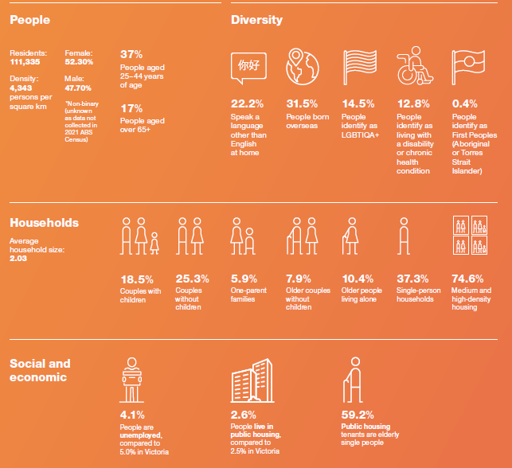
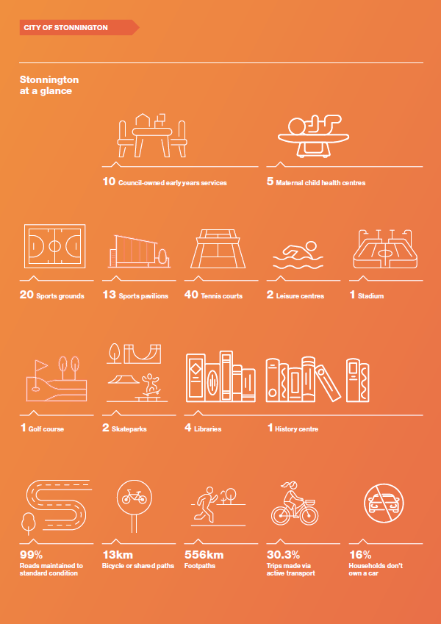
- International students
- Healthy eating

Our city

2 Neighborhood Houses

2 Youth Hubs

NOTE: Infographics will be updated with the most recent available data prior to the adoption of the strategy.

Our health and wellbeing
Better than the Victorian average
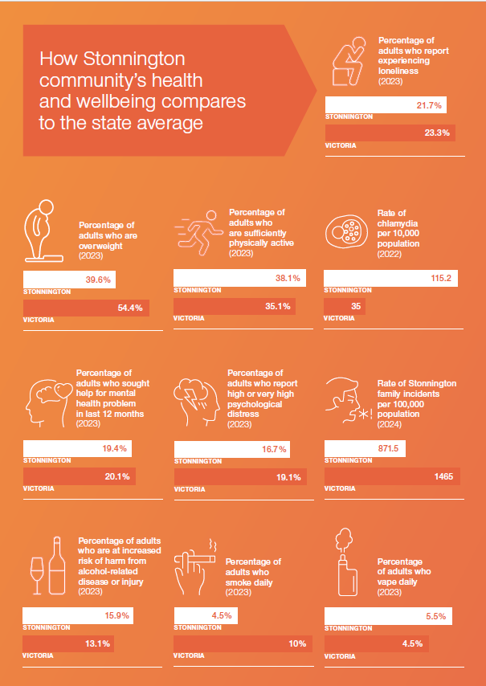
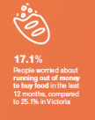

Worse than the Victorian average
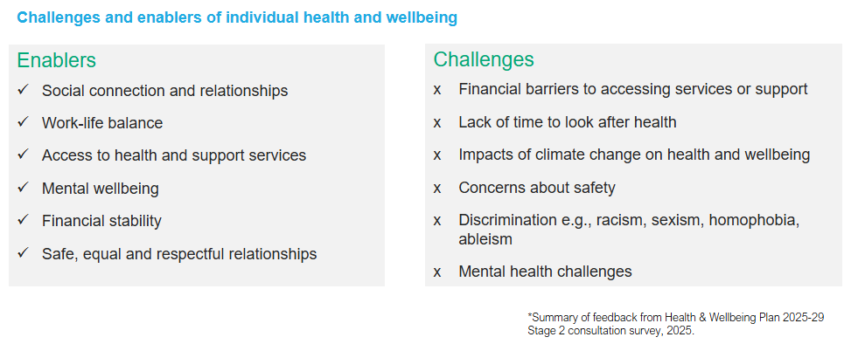

Our priorities
Based on what the data tells us, and what we’ve heard from our community and partners, we’ve identified three priorities that will guide our work over the next four years.
Priorities | What we want to achieve
Community safety and all forms of violence | Everyone feels safe, welcome and able to participate fully in community life
Community safety and all forms of violence | Violence, including family and gender-based violence, is not accepted and is actively prevented
Community safety and all forms of violence | Gender equality and respect are thriving in our community
Community safety and all forms of violence | Our community has access to safe, stable and affordable housing
Community safety and all forms of violence | Harm from alcohol, vaping and other drugs is reduced
Social connection and inclusion | Everyone has meaningful opportunities to connect and feel part of their community
Social connection and inclusion | Barriers to inclusion and participation are actively identified and reduced
Social connection and inclusion | Everyone feels seen, valued and safe to be themselves when participating in community life
Active and sustainable living | Everyone has the opportunity to be active
Active and sustainable living | Everyone has access to nutritious, affordable food
Active and sustainable living | Our community is staying well and building resilience in a changing climate.

Priority 1: Community safety and all forms of violence
COUNCIL PLAN OBJECTIVE
People are safe and able to fully participate in community life.

Why this matters
Feeling safe is one of the most essential foundations for good health and wellbeing. Improving safety is not just about reducing crime – it’s about creating public spaces where everyone feels welcome, respected and able to participate freely.
We know that safety isn’t experienced equally. Women are disproportionately impacted by gender-based violence, including physical, emotional and financial abuse, as well as coercive control. LGBTIQA+ communities, people from multicultural backgrounds, people with disability and older residents often face greater risks and report feeling less safe in public places. Racism, discrimination and gendered violence cause lasting harm and undermine trust and belonging.
Other factors, like alcohol and drug misuse, housing insecurity and social inequality, can increase the risk of harm and deepen existing disadvantage. We’re committed to shaping a city where everyone can live safely, free from discrimination and harm.

What we know
Safety | Family violence
- In 2024, there were 10,341 criminal incidents, a 19.8% increase from 2023.  South Yarra, Prahran, and Malvern East experienced the highest crime rates.  - Theft from vehicles was the most common crime.  - Perceptions of safety declined, with 75% feeling safe in 2024 compared to 81% in 2023.  - Women and non-binary people reported feeling unsafe at higher rates than men.  - The areas where people felt least safe were Windsor, Prahran, and South Yarra. | - In 2024, there were 1,028 family violence incidents, an 11.3% increase from 2023.  - Women accounted for 70% of those affected, with women aged 25–44 most likely to be impacted.  - A child was present in 20% of incidents.  - 84.2% of family violence occurred within residential properties.  - Men were responsible for 72% of incidents, mostly perpetrated by intimate partners.  - Alcohol was a likely or definite factor in 23.2% of incidents.  - Family violence is underreported in multicultural families.
Alcohol, other drugs and vaping | Gender inequity
- Stonnington has the fifth highest vaping prevalence in Victoria, with 8.3% of adults currently vaping compared to 6.1% statewide.  - 15.9% of adults are at increased risk of alcohol harm, above the state average of 13.1%.  - There were 1,124 ambulance attendances for alcohol and drug misuse in Stonnington, nearly double the state rate.  - In 2021, 720 assaults and 149 deaths in Stonnington were attributed to alcohol and illicit drugs. | - 82% of lone parents are women.  - 34.5% of women work part-time, compared to 21.1% of men.  - 21.8% of women do 15+ hours of unpaid domestic work weekly, versus 8.7% of men.  - The 2023-24 gender pay gap is 21.8%; women earn 78 cents for every dollar men make on average.
Housing and homelessness | Racism and discrimination
- In 2022-23, 538 people received specialist homelessness services.  - In November 2024, 13 people were sleeping rough, down from 21 in February 2024.  - About 1,712 people (2.6%) live in public housing, slightly above the Victorian average of 2.5%.  - In 2021, 8,315 people lived in low-income households, with 64.5% in lone-person households.  - 17.7% of low-income households experience rental stress.  - In 2021, 27.0% of renting households were under rental stress (paying over 30% of income on rent), slightly below the Victorian average of 30.9%. | - 14.1% of people reported experiencing discrimination in the past 12 months.  - 5.5% reported experiencing racism in the same period.  - Racism was identified as a key issue for young people in 2024

What we’ll do
Over the next four years, we’ll take targeted action to improve safety in public spaces, promote respectful relationships, and advocate for systems and supports that protect those most at risk.
We’ll continue to work closely with Victoria Police and local organisations to reduce harm, respond to family violence, and create safe, inclusive environments – especially for women, children, and gender-diverse people.
Importantly, we’ll also promote gender equity in everything we do, from sport and parenting programs to our own workplace practices, and support community-led initiatives that challenge harmful behaviours and attitudes.
What we want to achieve  (Objectives) | How we’ll do it  (Focus areas) | How we’ll measure progress  (Indicators)
1.1 Everyone feels safe, welcome and able to participate fully in community life. | - Foster partnerships to support an integrated approach to community safety.  - Improve safety in public spaces through lighting, design and visibility.  - Advocate for increased safety resources and better access to community-based health and support services.  - Promote community awareness of local safety issues and how to report concerns or seek help and prepare for emergencies.  - Monitor and respond to the safety concerns and lived experiences of priority groups  - Support campaigns and community initiatives that address racism, discrimination and hate-speech and conduct | - Crime: number and rate per 100,000 population of crime incidents  - Perception of safety: proportion of residents who feel a sense of safety and security in Stonnington.  - Racism/discrimination: rate per population of experiences of racism/discrimination
1.2 Violence, including family and gender-based violence, is not accepted and is actively prevented | - Promote community awareness of family, sexual and gender-based violence, its drivers and how to seek help  - Empower community members to speak up, intervene safely and challenge harmful attitudes and behaviours  - Support safe, inclusive and culturally appropriate responses for victim-survivors  - Embed Child Safe Standards and family violence prevention in Council policies, services and partnerships | - Family violence: number and rate per 100,000 population of family violence incidents  - Child Safety: compliance with Child Safe standard
1.3 Gender equality and respect are thriving in our community | - Promote gender equity and respectful relationships in settings like sport, early childhood, workplaces and parenting  - Increase visibility, inclusion and leadership of women and gender-diverse people in community life  - Engage men and boys as allies in promoting equality and challenging harmful norms  - Strengthen our internal capacity to model gender equity through policy, leadership and workplace culture  - Celebrate and promote awareness of gender diversity and intersectionality across the community | - Paid employment: percent of females in full-time paid employment  - Income parity: individual income quartiles, gender disaggregated.  - Unpaid work at home: percentage of adults doing >15hr unpaid domestic work at home, gender disaggregated  - Poverty: low-income households (less than $800 per week), gender disaggregated
1.4 Our community has access to safe, stable and affordable housing | - Advocate for more affordable and appropriate housing to meet local needs  - Advocate for stronger early intervention and access to services for people experiencing housing stress, especially renters and older adults  - Partner with local services to reduce homelessness, including through Stonnington Zero | - Rough sleeping: number of people on Launch Housing by-name list  - Rental stress: percentage of renter under rental stress (>30% of income on rent)  - Housing: percentage of people by how satisfied they are with their rental accommodation, experience rating of affordable decent housing.
1.5 Harm from alcohol, gambling, vaping and other drugs is reduced | - Increase understanding of the health and social impacts of alcohol, gambling, tobacco, vaping and other drugs  - Create environments that reduce exposure and harm, including second-hand impacts  - Strengthen local data, partnerships and place-based responses  - Advocate for stronger regulation of alcohol, vaping, tobacco and gambling | - Alcohol: percentage of people at lifetime risk of alcohol harm, percentage of ambulance attendances for alcohol related injury or illness, number of liquor licences  - Vaping/smoking: proportion of adult (18+ years) population, by smoking status  - Illicit drugs: rate of Illicit drug-related hospital admissions per 10,000 population  - Pharmaceutical drug harm: rate of pharmaceutical drug-related hospital admissions per 10,000 population  - Gambling: number of EGM (pokies) machines by LGA, net EGM expenditure lost by player by LGA
What this looks like in action
Some of the key things we’ll do over the next four years:
- Partner with Crime Stoppers to deliver a campaign in the Chapel Street precinct encouraging people to safely step in or speak up when they witness concerning behaviour and support licensed venues to deliver training to staff around preventing and responding to sexual harm.
- Partner with a Men’s mental health organisations to deliver initiatives that support boys and men to challenge harmful stereotypes of masculinity, promote mental health and wellbeing, and become allies in the prevention of violence.
- Support Council staff, local businesses and community groups to recognise signs of family violence and respond safely to disclosures, using resources from the ‘Are You Safe at Home?’ campaign.
- Strengthen Early Years and MCH programs that promote respect and gender equality.
- Advocate for increased services and supports, including housing for community members experiencing homelessness.
- Strengthen Council policy and local partnerships to prevent harm from alcohol, gambling, vaping, tobacco and other drugs, through clear guidance and coordinated community action.
- Promote smoke-free and vape-free environments by enhancing signage and visibility in key community spaces to support compliance with the Tobacco Act.

Guiding documents
Council | External
Community Safety Plan 2024-27  LGBTIQA+ Action Plan 2023-26  Disability Inclusion Action Plan 2023-26  Reconciliation Action Plan 2025-2027 *  Municipal Emergency Management Plan  Stonnington Homelessness Protocol  Stonnington Zero MOU | Neighbourhood Policing Framework, Victoria Police  Victorian Drug Harm Action Plan*  Victorian Tobacco legislation reform  Victorian Free from Violence Action Plan  Victorian Gender Equality Strategy and Action Plan 2024-27  Promoting Respect & Equity Together Strategy, WHISE  Men in Focus, Our Watch
*In development or review

Priority 2: Social connection and inclusion
COUNCIL PLAN OBJECTIVE
People are connected and feel they belong

Why is this important?
Feeling connected to others through friendships, family, community, or culture, helps us feel secure, supported and valued. It improves our mental health and gives us a sense that we are part of something bigger. But barriers like discrimination, language, age, disability, digital exclusion or housing circumstance can leave people feeling isolated or invisible.
We want Stonnington to be a place where no one feels alone or excluded. That means removing those barriers where we can – creating inclusive spaces, making services easy to access, and celebrating the diversity that strengthens our community.

What we know
Mental wellbeing | Community connection
- In 2023, 81.4% of people reported high or very high life satisfaction.  - 16.7% of adults experienced high to very high psychological distress, lower than the Victorian average of 19.1%.  - 8.5% reported having a long-term mental health condition.  - 19.4% of adults sought help for a mental health issue in the past 12 months.  - Mental health issues are believed to be underreported by men and multicultural communities due to cultural barriers. | - 27% of residents identified strong community and social cohesion as important for a good place to live but reported lower experience of this in Stonnington.  - 15.9% of people volunteer in the community.  - 21.7% of residents reported experiencing loneliness.
Multiculturalism | Diversity
- 31.5% of residents were born overseas, with 24% born in non-English speaking countries.  - 22.2% speak a language other than English at home, primarily Mandarin, Greek, and Cantonese.  - 78.4% agree that multiculturalism improves life in Stonnington. | - 0.4% (373 people) identify as First Peoples (Aboriginal and Torres Strait Islander).  - 14.5% of adults identify as LGBTIQA+.  - 12.8% of adults have a disability or long-term health condition.

What we’ll do
We’ll focus on reducing isolation and creating more ways for people to connect and participate. This includes supporting inclusive events, strengthening partnerships with local organisations, and ensuring services are culturally safe, welcoming and accessible.
We’ll continue to promote reconciliation, multiculturalism, disability inclusion and LGBTQIA+ pride, and work to remove the barriers that prevent people from joining in. Whether it’s through volunteering, arts and culture, lifelong learning or local activities, we’ll support opportunities for people to build connections and contribute in ways that are meaningful to them.
We’ll also strengthen our own capacity to serve a diverse community, making sure our services are inclusive by design, and that people who face barriers to participation can access them with easily and with confidence.
What we want to achieve  (Objectives) | How we’ll do it  (Focus areas) | How we’ll measure progress  (Indicators)
2.1 Everyone has meaningful opportunities to connect and feel part of their community | - Create a range of opportunities for people to connect with others through our libraries, events, local programs and everyday interactions  - Support initiatives that help people experiencing vulnerability to meet others and build relationships  - Enable and grow volunteering across our community as a way to connect, contribute and build local networks  - Empower people to actively participate in decisions about their lives and communities | Community connection: sense of community importance/ experience, percentage of adults experiencing loneliness.  Mental wellbeing: percentage of adults by; level of psychological distress and satisfaction with life  Volunteering: percentage of adults who volunteer
2.2 Barriers to inclusion and participation are actively identified and reduced | - Make services and information that support mental and physical wellbeing easier to find, access and navigate.  - Address barriers to participation such as disability, language, digital access, cost and discrimination  - Ensure community programs and services are responsive to a diverse range of needs and life experiences  - Improve understanding about the drivers of disadvantage, discrimination and exclusion | Access to services and facilities: % of respondents unable to access community facilities and services  Help seeking: percentage of people seeking help for mental health problem, number of people utilising aged care navigation supports and language services
2.3 Everyone feels seen, valued and safe to be themselves when participating in community life | - Deliver events, programs and activities that celebrate diverse cultures, histories and identities  - Use inclusive language, imagery and messaging to support welcoming and culturally safe environments  - Include diverse community voices in the design and delivery of programs, services and events  - Support inclusive practice and create culturally safe, welcoming environments across Council services, facilities and programs  - Promote positive community attitudes that challenge stigma, racism and discrimination | Community perception: satisfaction with community and cultural activities.  Social cohesion: percentage of adults who agree multiculturalism makes life in Stonnington better
What this looks like in action
Some of the key things we’ll do over the next four years:
- Deliver digital literacy programs, including cyber safety, to build skills and confidence among priority populations through libraries and community settings.
- Grow the Volunteer Stonnington platform to enhance volunteer engagement, support community organisations, and foster capacity-building initiatives.
- Investigate opportunities for the co-location of support services in council facilities to better meet community needs.
- Develop a community-facing Inclusive Language and Imagery Guide to promote respectful communication and encourage broader participation.
- Build the capacity of local businesses to employ people with disability by sharing inclusive employment resources and training and partnership opportunities.
- Partner to pilot an after-school Homework Club at the Hub for school-aged students living on the Horace Petty Estate.
- Advocate for improved access to local mental health and sexual and reproductive health services.

Guiding documents
Council | External
LGBTIQA+ Action Plan 2023-26  Disability Inclusion Action Plan 2023-26  Reconciliation Action Plan 2025-2027 *  Ageing Well Action Plan 2024-27  Libraries Plan 2024-26  Volunteering Policy | Victoria’s Multicultural Policy Statement 2017  Pride in our future: Victoria’s LGBTIQA+ strategy 2022–2032  Inclusive Victoria: State Disability Plan 2022–2026  Victorian Gender Equality Strategy and Action Plan 2024-27
*In development or review

Priority 3: Active and sustainable living
COUNCIL PLAN OBJECTIVE
People lead active and healthy lifestyles

Why this matters
Being active supports almost every aspect of our health, from physical fitness to mental wellbeing, social connection and healthy ageing. Being active can look different for everyone: a walk with friends, joining a local team, riding to work, or playing in the park with your kids.
We want to make it easier for everyone to stay active in ways that work for them. That means removing barriers like cost, safety, and physical access – and ensuring places, facilities and programs are welcoming for all ages, abilities and backgrounds.
We also recognise the growing impact of climate change on health. From heat stress to air quality and food security, our changing environment is shaping how we live, move and stay well. What we know about our community
Physical health | Climate change and environment
- Asthma, arthritis, heart disease, and cancer are the most common long-term physical health conditions.  - 39.6% of residents are overweight or obese, compared to 54.4% across Victoria.  - Stonnington residents are more physically active than the Victorian average. 38.1% of adults meet the national guideline of 150+ minutes of moderate to vigorous activity per week, higher than the Victorian average of 35.1%.  - Only 9.6% of adults report no moderate to vigorous activity, significantly lower than the state average of 16.8%. | - 96% of residents believe in climate change, higher than the Victorian average of 91%.  - About one-third feel they are already experiencing climate change impacts, while most believe these effects won’t occur within their lifetimes.  - Climate change-related mental health impacts, including eco-anxiety, have been identified.  - In 2024, the top reported climate-related health issues were pollen allergies, food availability concerns, and heat stress/heatstroke.  - 30.3% of trips within the municipality are made via active transport.  - 33.2% of residents reported severe sunburn on multiple occasions in the past 12 months.  - With 25% tree canopy coverage, Stonnington ranks among Melbourne’s municipalities with the highest canopy levels.
Food security and nutrition | Participation
- 26.9% of adults consume soft drinks or sugar-sweetened beverages daily.  - 5.1% of people experienced running out of food in the past 12 months and couldn’t afford to buy more.  - 17.1% of people worried about running out of money to buy food. | - In 2024-25, 6,882 people participated in organised sports across Stonnington.  - Female participation is significantly lower than male, at 23.8% compared to 76.7%.  - Nearly 1,200 volunteers are registered with Stonnington sports clubs.  - Netball is the most popular sport for females under 18, with AFL, soccer, and cricket also among the top field sports for this group.  - Females make up 43.7% of tennis participants.  - Over 300 participants identify as coming from diverse cultural and linguistic backgrounds.  - Popular sports for older adults in Stonnington include swimming, bowling, tennis, and golf.

What we’ll do
We want to make it easier for people of all ages, abilities and backgrounds to lead active, healthy lives – whether that’s through sport, recreation, walking and cycling, or simply enjoying time outdoors.
Over the next four years, we’ll focus on expanding inclusive sport and recreation options, improving access to affordable, nutritious food, and promoting healthier choices.
We’ll also help our community adapt to a changing climate by promoting active transport and designing neighbourhoods that support local living and climate-resilience.
What we want to achieve  (Objectives) | How we’ll do it  (Focus areas) | How we’ll measure progress  (Indicators)
3.1 Everyone has the opportunity to be active | - Design neighbourhoods, open spaces and facilities that make it easy to be active every day  - Provide inclusive and welcoming places and programs for sport, recreation and unstructured activity, such as running or dog walking.  - Partner with community organisations to reduce participation barriers, especially for priority groups  - Create culturally safe opportunities for First Peoples, multicultural communities and people with disability to be active  - Build community confidence and awareness to try new ways of being active  - Promote safe participation and reduce risk of injury through design and education | Physical activity: self-reported health status, proportion of adults engaging in sufficient levels of moderate exercise  Active recreation: community satisfaction with council managed recreation facilities, parks, plazas and open/green spaces.  Active transport: percentage of trip made via active transport  Participation: proportion of priority population participating in organised/ community sport
3.2 Everyone has access to nutritious, affordable food | - Increase equitable access to nutritious, affordable food and drink options across the community  - Support programs that strengthen food security for priority populations  - Strengthen the capacity of local food relief services to provide nutritious and culturally appropriate foods  - Promote healthy eating and drinking through education and local campaigns | Food security: proportion of adults who were worried about running out of money to buy food in the last 12 months.  Healthy food and drink: proportion of adult meeting vegetable intake guidelines, proportion of adults consuming sugar-sweetened soft drink daily, percentage adults overweight
3.3 Our community is staying well and building resilience in a changing climate | - Support community understanding and response to key health impacts of climate change, including extreme heat, poor air quality and flooding  - Deliver climate adaptation and mitigation actions like increasing shade, improving drainage, and designing buildings and public spaces that stay safe and comfortable in extreme weather  - Plan neighbourhoods and transport systems that support climate-friendly travel and local living | Climate indicators: liveability index score, percentage of adults with belief in climate change and agree they will feel its impacts in their lifetime, percentage of adults confident in adapting to effects of climate change. Number of trees planted
What this looks like in action
Some of the key things we’ll do over the next four years:
- Co-design inclusive programs that support participation among those least likely to be active, including older adults, multicultural communities, people with disability and children.
- Use policy and licensing mechanisms to support growth of women and girls’ teams in community clubs.
- Integrate falls prevention education into existing exercise programs for older adults.
- Deliver injury prevention education for new parents, covering topics such as sun protection, water safety and emergency care.
- Partner to deliver nutrition education at the Hub and explore establishing a regular breakfast club for students experiencing food insecurity.
- Investigate opportunities to improve access to safe and nutritious food for vulnerable groups.
- Develop Healthy Food and Drink Guidelines for council-managed facilities, events, and community groups.
- Audit UV-protective shade and heat-reflective surfaces in playgrounds and recreation spaces to inform upgrades.
- Engage with children and young people to understand their climate concerns and amplify their voices in climate action.

Guiding documents
Council | External
Environment strategy*  Transport strategy*  Active Stonnington Action Plan*  Fair Access Policy 2024-27  Ageing Well Action Plan 2024-27  LGBTIQA+ Action Plan 2023-26  Reconciliation Action Plan 2025-27*  Disability Inclusion Action Plan 2023-26  Municipal Emergency Management Plan  Domestic Animal Management Policy* | Fair Access Policy Roadmap  Inclusive Victoria: state disability plan 2022–2026  State Emergency Management Plan
*In development or review

Monitoring and Evaluation
We’re committed to making sure this Strategy delivers real outcomes for our community, particularly our priority populations.
We’ll track our progress using measures aligned to each priority area, and wherever possible, compare our results with state and national benchmarks. These measures will help us see what’s working, where we need to adjust, and how we can better support our community.
We’ll share progress through our CEO Quarterly Update and Annual Report and undertake a more in-depth evaluation in the Strategy’s final year. We will periodically review our performance indicators as appropriate, and these will be adjusted as needed through our annual and corporate reporting. We’ll also continue to improve the way we collect and use local data, so we can deepen our understanding of community needs and ensure our efforts are making a meaningful difference.

References
- Commission on Social Determinants of Health (2008), Closing the gap in a generation: health equity through action on the social determinants of health. Final report of the Commission on Social Determinants of Health. Geneva: WHO.
- Department of Health and Human Services (2023), Victorian public health and wellbeing plan 2023-27, State Government of Victoria

Data sources
Data gives us a clearer picture of where things are working well and where we need to focus our efforts. We have drawn on a broad range of sources to understand the social and health trends shaping our city, including:
Victorian Population Health Survey (VPHS)
Victorian Agency for Health Information. (2024). Victorian Population Health Survey 2023- Limited data set release. State Government of Victoria.
Crime Statistics Agency (CSA)
Crime Statistics Agency. (2025). Crime and Family Violence Dashboard. State Government of Victoria.
.id (Informed Decisions)
Informed Decisions. (2025). Community Profile (based on 2021 Census data).
Informed Decisions. (2025). Community Views (based on 2024 survey data).
Victorian Integrated Survey of Travel and Activity (VISTA)
Department of Transport and Planning. (2022). Victorian Integrated Survey of Travel and Activity. State Government of Victoria.
Other sources
Turning Point. (2022). AODstats.
Andersson, T., Ward, A. C., Bayly, M., & Mitsopoulos, E. (2022). Prevalence of tobacco smoking and vaping by Victorian LGA. Centre for Behavioural Research in Cancer, Cancer Council Victoria.
Victorian Department of Health. (2023). Local Government STI Surveillance Report.
Homes Victoria. (2023). Local Government Housing Data Dashboard.
Resilient Youth Australia & University of Adelaide. (2023). Resilient Youth Survey.
City of Stonnington
City of Stonnington. (2024). Community Satisfaction Survey.
City of Stonnington. (2025). Health and Wellbeing Survey.
City of Stonnington. (2024). Annual Report 2023–24.
Launch Housing. (2024). Stonnington Zero Report, Oct–Nov 2024.

Appendix 1
HEALTH AND WELLBEING POLICY CONTEXT

State Legislation

- Victorian Public Health and Wellbeing Act 2008
- Climate Change Act 2017
- Gender Equality Act 2020
- Local Government Act 2020

Global
United Nations Sustainable Development Goals

National
National Preventive Health Strategy 2021–2030

State
- Victorian public health and wellbeing plan 2023–27
- Wellbeing in Victoria: a plan to promote good mental health 2024–34*(NEW: in development)
- Victorian sexual and reproductive health and viral hepatitis strategy 2022–30
- Victorian. And proud of it: Victoria’s multicultural policy statement 2017
- Victorian Multicultural Health Action Plan 2023–27
- Pride in our future: Victoria’s LGBTIQA+ strategy 2022–2032
- Inclusive Victoria: state disability plan 2022–2026
- Our equal state: Victoria’s gender equality strategy and action plan 2023–2027
- Free from violence: Victoria’s strategy to prevent family violence
- Our promise, your future: Victoria’s youth strategy 2022–2027
- The Victorian Closing the Gap Implementation Plan 2021-2025*(in development)
- Vic Health Strategy 2023-2033
- VACCHO Strategy 2021-26: Standing on solid ground
- Ageing well in Victoria: an action plan for strengthening wellbeing for senior Victorians 2022-2026.

Victorian Health and Wellbeing Plan 2023–27 priorities:
- Improving sexual and reproductive health
- Reducing harm from tobacco and e-cigarette use
- Improving wellbeing
- Increasing healthy eating
- Increasing active living
- Reducing harmful alcohol and drug use.
- Tackling climate change and its impacts on health
- Preventing all forms of violence
- Decreasing antimicrobial resistance across human and animal health
- Reducing injury

Local
- South-Eastern Public Health Unit: Population health catchment plan 2023-28
- WHISE: Good Health Down South Strategy 2021-25* (in development)
- WHISE: Promoting Respect and Equity Together (PRET) Strategy 2021-25* (in development)
- BHN: Better Health Network: Inaugural Strategic Plan 2023-2026 (in development)

Stonnington Health and Wellbeing Strategy 2025-29

Appendix 2
Priority Populations | Factors that impact health and wellbeing outcomes
Women and girls | Women and girls report feeling less safe in public spaces, limiting their ability to be active and socially connected. Gendered expectations, care responsibilities and experiences of discrimination can affect mental health, participation in sport and active living and access to social activities. Policy and community capacity building can address drivers of inequality and promote participation and safety of women and girls.
LGBTIQA+ and gender diverse people | Many LGBTIQA+ people report feeling unsafe or excluded in public settings and community programs. Fear of discrimination can limit involvement in sport, recreation, or seeking help. Supportive, visible community spaces and inclusive programs are essential to build cultural safety, belonging, and social connection.
Young people | Young people benefit from being active and socially connected but may lack safe, inclusive spaces to do so. Concerns about peer pressure, mental health, and online harms can impact wellbeing. Engaging youth in co-designing services and places supports resilience, safety, and positive wellbeing.
Older adults 65+ | Older people often face barriers to staying active including physical limitations, and fear of crime or falls. Social isolation is a key issue, especially for those living alone. Supportive environments, group programs, and safe walkable spaces support healthy ageing and connectedness.
People with a disability | People with disability may be excluded from active living opportunities due to physical, attitudinal or communication barriers. Perceptions of safety and access can limit independence. Universal design, accessible facilities and programs, and community education help foster inclusion and equity.
First peoples | Aboriginal and Torres Strait Islander communities experience systemic barriers to health and wellbeing, including the ongoing impacts of colonisation, racism, and intergenerational trauma. Strong cultural identity and connection to Country are key strengths. Supporting self-determination and partnering with Traditional Owners are essential to improving health outcomes and creating culturally safe spaces.
Multicultural Communities | Multicultural communities may face language, literacy and cultural barriers that impact accessing and navigating health and social service systems. They are typically underrepresented in local and state-wide health services and mainstream sport, which contribute to health inequality and poorer outcomes. Some cultural groups have higher prevalence of chronic illness, experience social isolation, racism or discrimination. Culturally responsive and inclusive programs, services and environments are crucial for building trust, improving health outcomes and strengthening social connection.
Low-income households
  Cost is a major barrier to active living and social participation, whether it’s joining a sport club, taking public transport, or affording devices to connect online. These challenges can increase social isolation and reduce participation and inclusion. Policies that reduce cost and improve local access can support wellbeing and equity.
People who live in low socio-economic areas and public housing
  Residents in low-SES areas often experience fewer green spaces, poorer infrastructure, and higher crime rates, which affect active living and perceptions of safety. Community-led initiatives and investment in public spaces, lighting, and programs are key to fostering a sense of pride, safety, and inclusion.
People who are homeless or at risk of homelessness | Without stable housing, people face constant safety risks and few opportunities to stay active or socially connected. Stigma and exclusion from public spaces further isolate them. Providing trauma-informed, and wrap-around supports is vital for supporting wellbeing and reducing homelessness.
People with low digital literacy or access to technology | As services and social opportunities increasingly shift online, people without digital access or skills risk being left behind. This limits their ability to stay connected, informed, and engaged in community life, both on and off-line, and increases vulnerability to cyber scams. Promoting digital inclusion is essential to ensure equitable access to health and wellbeing services and supports.

Appendix 3
Health and Wellbeing Indicators Framework
Priority | Objective | Indicator | Target (2029) | Source | Frequency
Community Safety and all forms of violence | 1.1 Everyone feels safe, welcome and able to participate fully in community life. | number of crime incidents |  | CSA | Yearly
Community Safety and all forms of violence |  | rate per 100,000 population of crime incidents |  | CSA | Yearly
Community Safety and all forms of violence |  | % of adults who feel a sense of safety and security in Stonnington, gender disaggregated |  | CV | 2- yearly
Community Safety and all forms of violence |  | rate per population of experiences of racism |  | VPHS | 3-yearly
Community Safety and all forms of violence |  | rate per population of experiences of discrimination |  | VPHS | 3-yearly
Community Safety and all forms of violence | 1.2 Violence, including family and gender-based violence, is not accepted and is actively prevented | number of family violence incidents |  | CSA | Yearly
Community Safety and all forms of violence |  | rate per 100,000 population of family violence incidents |  | CSA | Yearly
Community Safety and all forms of violence |  | compliance with Child Safe standard |  | Stonnington | Yearly
Community Safety and all forms of violence | 1.3 Gender equality and respect are thriving in our community | % of adults in full-time paid employment, gender disaggregated | women | Census | 5-yearly
Community Safety and all forms of violence |  | individual income quartiles, gender disaggregated | women | Census | 5-yearly
Community Safety and all forms of violence |  | % of adults doing >15hr unpaid domestic work at home, gender disaggregated | women | Census | 5-yearly
Community Safety and all forms of violence |  | % of low-income households (less than $800 per week), gender disaggregated | women | Census | 5-yearly
Community Safety and all forms of violence | 1.4 Our community has access to safe, stable and affordable housing | number of people on Launch Housing by-name list |  | Zero | Annual
Community Safety and all forms of violence |  | % of renter under rental stress (>30% of income on rent) |  | Census | 5-yearly
Community Safety and all forms of violence |  | % of people by how satisfied they are with their rental accommodation |  | VPHS | Yearly
Community Safety and all forms of violence |  | experience rating of affordable decent housing. |  | CV | 2- yearly
Community Safety and all forms of violence | 1.5 Harm from alcohol, gambling, vaping and other drugs is reduced | % of people at lifetime risk of alcohol harm |  | VPHS | 3-yearly
Community Safety and all forms of violence |  | % of ambulance attendances for alcohol related injury or illness |  | AOD | Yearly
Community Safety and all forms of violence |  | number of liquor licences in IPO3 |  | LCV | Yearly
Community Safety and all forms of violence |  | % of adult (18+ years) population, by smoking status |  | VPHS | 3-yearly
Community Safety and all forms of violence |  | rate of Illicit drug-related hospital admissions per 10,000 population |  | AOD | Yearly
Community Safety and all forms of violence |  | rate of pharmaceutical drug-related hospital admissions per 10,000 population |  | AOD | Yearly
Community Safety and all forms of violence |  | number of EGM (pokies) machines by LGA |  | VGCCC | Yearly
Community Safety and all forms of violence |  | net EGM expenditure lost by player by LGA |  | VGCCC | Yearly
Social connection and inclusion | 2.1 Everyone has meaningful opportunities to connect and feel part of their community | sense of community importance/ experience |  | CV | 2-yearly
Social connection and inclusion |  | % of adults experiencing loneliness. |  | VPHS | 3-yearly
Social connection and inclusion |  | % of adults by level of psychological distress |  | VPHS | 3-yearly
Social connection and inclusion |  | % of adults by; satisfaction with life |  | VPHS | 3-yearly
Social connection and inclusion |  | % of adults who volunteer |  | Census | 5-yearly
Social connection and inclusion | 2.2 Barriers to inclusion and participation are actively identified and reduced | % of respondents unable to access community facilities and services |  | CV | 2-yearly
Social connection and inclusion |  | % of people seeking help for mental health problem, |  | VPHS | 3-yearly
Social connection and inclusion |  | number of people utilising aged care navigation supports |  | Stonnington | Yearly
Social connection and inclusion |  | number of people utilising language services |  | Stonnington | Yearly
Social connection and inclusion | 2.3 Everyone feels seen, valued and safe to be themselves when participating in community life | community satisfaction score with community and cultural activities. |  | CSS | Yearly
Social connection and inclusion |  | % of adults who agree multiculturalism makes life in Stonnington better |  | VPHS | 3-yearly
Active and sustainable living | 3.1 Everyone has the opportunity to be active | self-reported health status |  | VPHS | 3-yearly
Active and sustainable living | 3.1 Everyone has the opportunity to be active | % of adults engaging in sufficient levels of moderate exercise |  | VPHS | 3-yearly
Active and sustainable living | 3.1 Everyone has the opportunity to be active | community satisfaction score with parks, public plaza and open/green space meeting their needs |  | CV
Active and sustainable living | 3.1 Everyone has the opportunity to be active | community satisfaction score with council managed recreation facilities |  | CSS | Yearly
Active and sustainable living | 3.1 Everyone has the opportunity to be active | % of trip made via active transport |  | VISTA | Yearly
Active and sustainable living | 3.1 Everyone has the opportunity to be active | Proportion of priority population participating in organised/ community sport |  | Stonnington | Yearly
Active and sustainable living | 3.2 Everyone has access to nutritious, affordable food | % of adults who were worried about running out of money to buy food in the last 12 months.
Active and sustainable living | 3.2 Everyone has access to nutritious, affordable food | % of adult meeting vegetable intake guidelines |  | VPHS | 3-yearly
Active and sustainable living | 3.2 Everyone has access to nutritious, affordable food | % of adults consuming sugar-sweetened soft drink daily, |  | VPHS | 3-yearly
Active and sustainable living | 3.2 Everyone has access to nutritious, affordable food | % adults overweight |  | VPHS | 3-yearly
Active and sustainable living | 3.3 Our community is staying well and building resilience in a changing climate | liveability index score |  | CV | 2-yearly
Active and sustainable living |  | % of adults with belief in climate change |  | CV | 2-yearly
Active and sustainable living |  | % of adults that agree they will feel its impacts in their lifetime |  | CV | 2-yearly
Active and sustainable living |  | % of adults confident in adapting to effects of climate change |  | CV
Active and sustainable living |  | number of trees planted |  | Stonnington | Yearly

Source Key
Abbreviation | Data Set | Organisation
Census | 2021 Australian Census | Australian Bureau of Statistics
VPHS | Victorian Population Health Survey | Victorian Department of Health
CSA | Crime Dashboard | Crime Statistics Agency
AOD | AOD Stats | Turning Point
VISTA | Victorian Integrated Survey of Travel and Activity | State Government of Victoria
CV | Community Views Survey | Profile ID
CSS | Community Satisfaction Survey | City of Stonnington
HV | Local Government Housing Data Dashboard. | Homes Victoria
Zero | Stonnington Zero Report | Launch Housing
VGCCC | Monthly expenditure data by Local Government Area | Victorian Gambling and Casino Control Commission

Data note: All data sources are listed on page 26. LGBTIQA+ and disability data in this infographic is based on responses from the 2023 Victorian Population Health Survey. These figures differ from the 2021 ABS Census, which measured need for assistance rather than self-reported disability identity. The 2021 Census did not collect information on LGBTIQA+ status or gender identity.

